**Documentation of App Setup**

### **A) Manifest Structure**

The app was developed by Android Studio, please see the structure of Build Gradle and Android Manifest

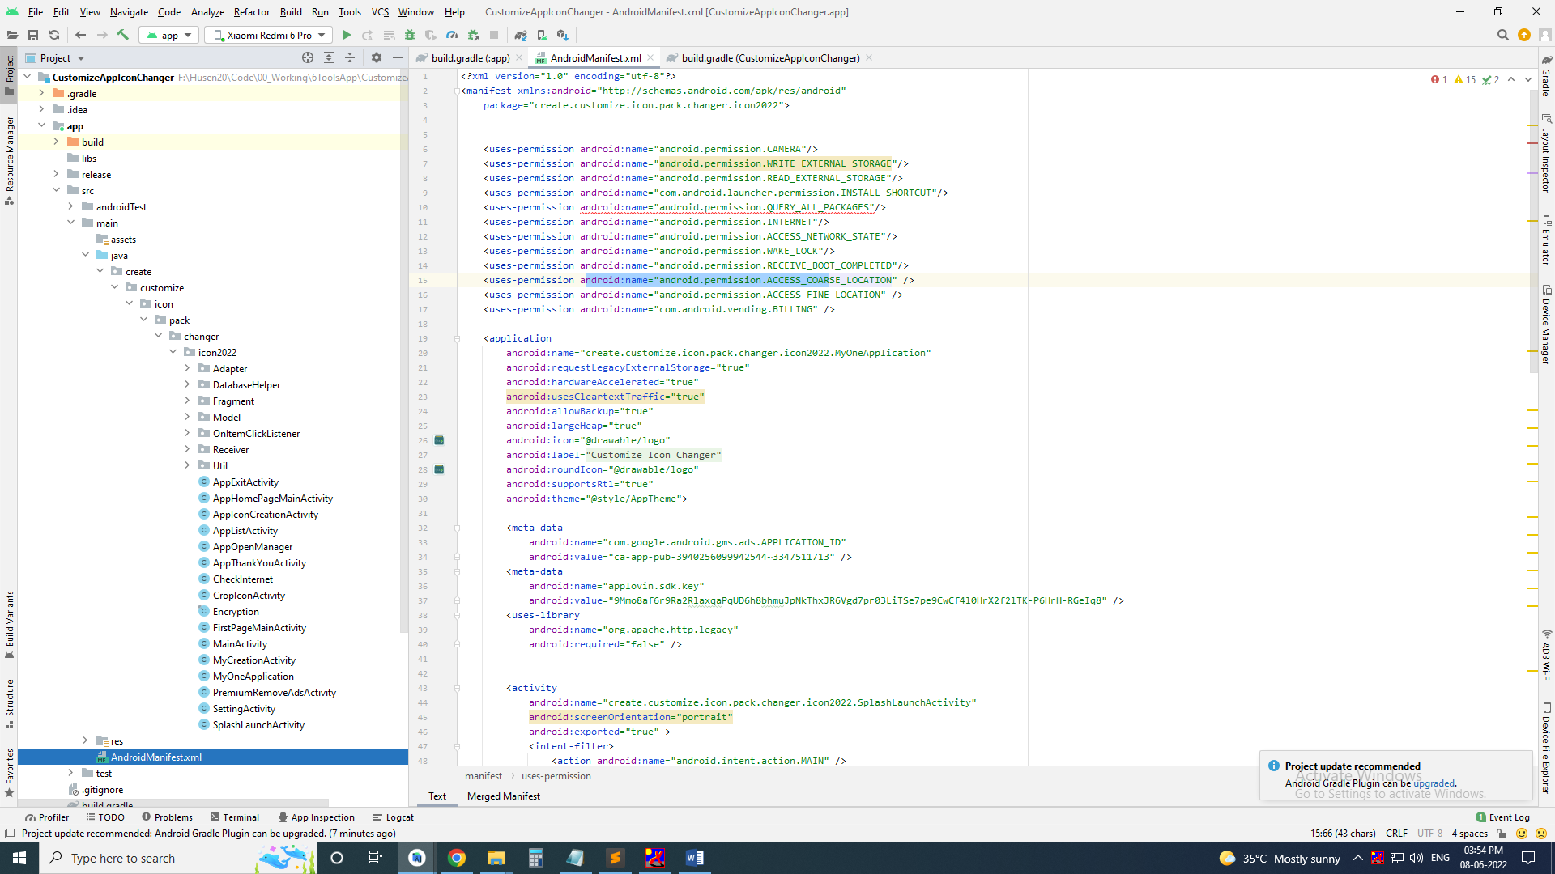

### **B) Change Ads IDs**

Go to MyApplication.java at ads folder and replace ids with your AdMob, Facebook & Applovin MAX ads

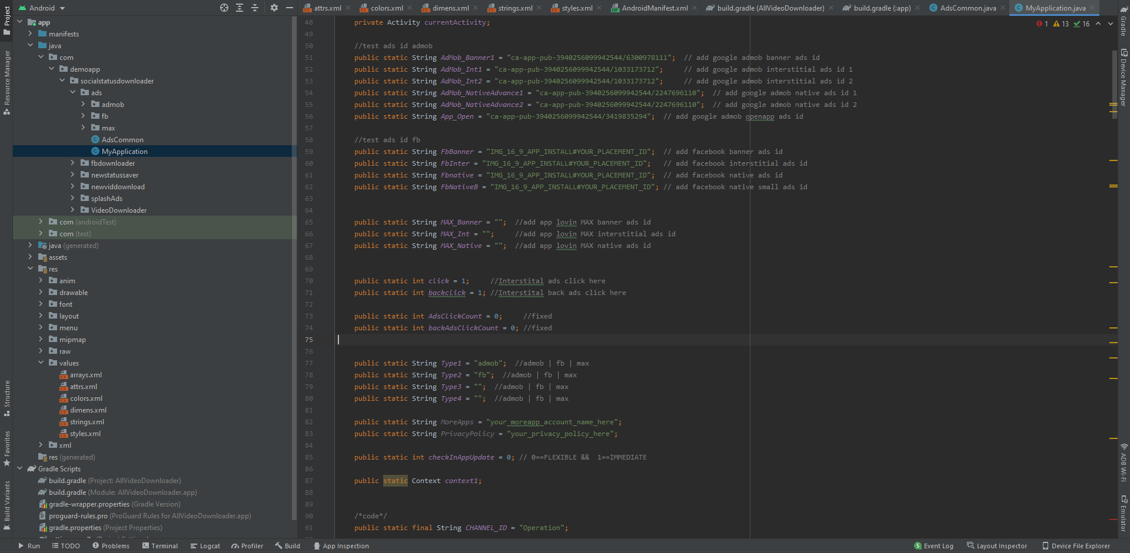

Type is define priority of ads

Ex 1: Single Ads Type1 == admob or fb

Ex 2: Type1 == admob & Type2 == fb, Google AdMob banner, inter, native are show but ads are failed or not show then show fb ads because type 2 == fb

Ex 3: Type1 == fb & Type2 == admob, Facebook banner, inter, native are show but ads are failed or not show the show AdMob ads because type 2 == admob

### **C) Change Skin of Apps**

**How to change Skin**

1. Go to res/drawable find & change image that you want

2. Go to res/layout/ find and change layout of app screen

### **D) Change package name**

**How to change package name**

